Game Design Document

Marcello Kuenzler

March 2020

Revision 2.0

This game is in the classic brick-breaking genre. The player is given a paddle and must bounce a ball into bricks. They gain points for each brick destroyed and try to get the highest score. The game has no definitive end and stops when the player runs out of lives.

Story

As this is just a simple gameplay-based game, the story is non-existent, and this section is not applicable to this game.

Theme

The game is based on simple shapes, colors and sounds. It has a simple background music to keep the user engaged, as well as a breaking sound when a brick is broken. The bricks will be in four colors: yellow, blue, green and red. They will look the same except for the color, and the color has no bearing on the gameplay. When broken they will deteriorate from the outside in, and then disappear. The paddle will be a simple black bar. The ball will be blue, half shaded a different blue so that a rolling effect can be simulated. Powerups will be simple colored circles with a P on them: red, blue and yellow, with a pulsating white circle around it. The color of the circle will decide the benefit imbued by collecting the powerup. Examples of the brick, powerup and ball are shown in figure 1. In revision 2.0, all sprites and sounds will be collected in a datafile stored with the game.

FIGURE 1 – Sprites



The sound for the breaking sound was obtained from <https://freesound.org/people/Craxic/sounds/204692/>. It was created by user Craxic and was published on October 31, 2013.

The sprite class was originally obtained from the source code and materials supplied with the textbook Game Programming All in One written by Jonathan S. Harbour. It was then altered for this game.

The background music was also obtained from the source code and materials supplied with the textbook Game Programming All in One written by Jonathan S. Harbour.

Menus

There are no actual menus in this game. There will be a start up screen with the name of the game, the company and company logo, and copyright information. Balls and powerups will be strewn around the information to show what the player can expect. After this the help screen will be displayed, describing how to play the game. After this screen gameplay begins. The help screen can be called again at anytime during gameplay to either review or pause gameplay. After all lives are lost a game over screen will be displayed, allowing the player to restart or quit the game. The game can be quit at any time, in any of these screens.

The company logo was obtained from <https://clipart.me/animals-wildlife/jumping-goat-clip-art-42772>. It was created by an unknown author and published on an unknown date.

Playing a Game

At the start of a level, the level is populated with the paddle and the correct number of bricks. The bricks are in rows, with levels one through four having one through four rows of bricks, top to bottom, and levels five and up having random rows of bricks activated between rows two and eight. Row one will always be filled. The colors of the bricks will be randomized in every level. A display at the bottom left of the screen will show the current score, lives and bricks. Once gameplay has started, a ball will be dropped into the center of the level and will roll directly down. The player controls the paddle and can move it left or right. The ball will bounce off the paddle as well as any brick and the left, right and top of the screen. If the paddle is moving when a ball is hit, it will alter the angle of the ball’s movement. If a ball hits the bottom of the screen, it is lost. If this is the last ball in play, a life is lost, and a new ball is placed. When a brick is hit, it will animate through its destruction, play its sound effect, and give the player one point. There will also be a chance to drop a powerup, which is inversely proportional to the level, to both add difficulty as levels rise and to limit the number of powerups when there are many bricks. Which powerup is dropped is randomized between the three. The three powerups, blue, yellow and red, give an extra life, spawn an extra ball at the center headed down, and double the width of the paddle for approximately 20 seconds. An indicator at the bottom right will display if the double width paddle powerup is activated. After all bricks are destroyed, the next level is started. Score is kept between levels, and the ball speed is increased every level. The levels are endless, and random starting with level five, and eventually the ball speed will exceed the player’s skill and the player will lose all lives, ending in game over.

The layout of the gameplay screen is show in figure 2, with the bricks being at the top, the level information, including lives, score, bricks left and powerup indicator, at the very bottom, and above that the paddle area, which is where the paddle can be.

The text of the help screen is shown in figure 3, which explains the rules of the game.

FIGURE 2 – Layout

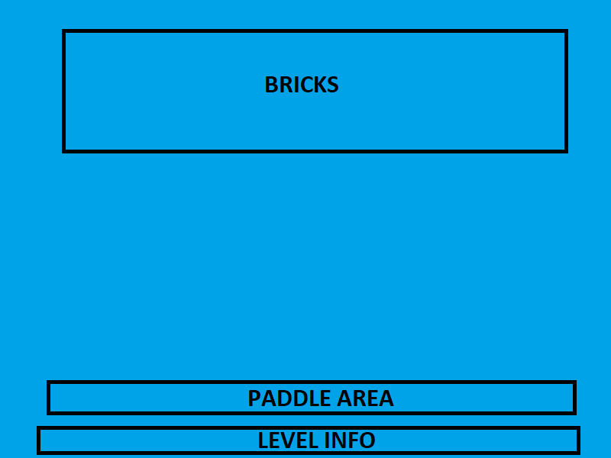

FIGURE 3 – Help Screen

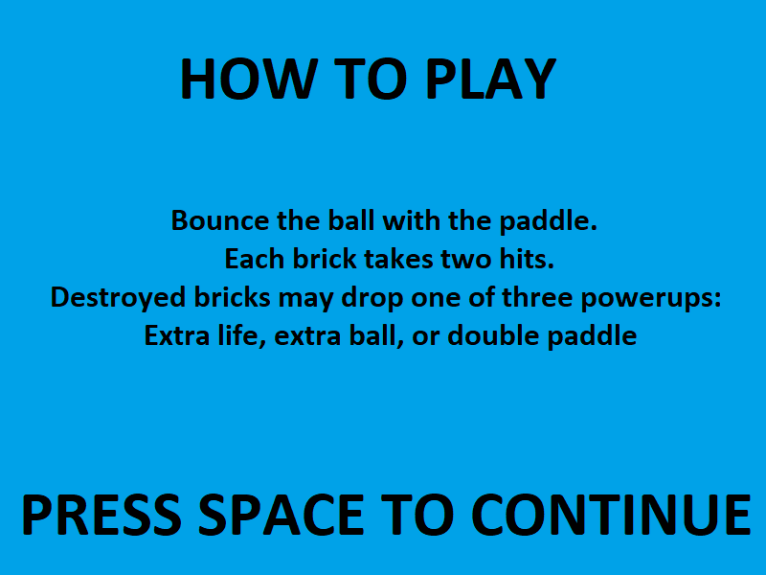

Characters and NPC

There are no characters or NPC’s within this game, so this section is not applicable.

Artificial Intelligence Overview

This game contains no AI programming, so this section is not applicable.

Conclusion

This is just a simple endless game to provide some fun, while attempting to get the best score the player can get, alone or within their group.